

SIMATS ENGINEERING

Saveetha Institute of Medical and Technical Sciences
Chennai- 602105

Student Name: Juhi Surin Reg. No.: 192525148
Course Code: CSA1519 Slot: C
Course Name: Cloud Computing and Big Data Analytics
Course Faculty: Dr. Govindasamy C
Project Title: Performance Comparison of Virtualized and Traditional Cloud Gaming Infrastructure
Module Photographs:
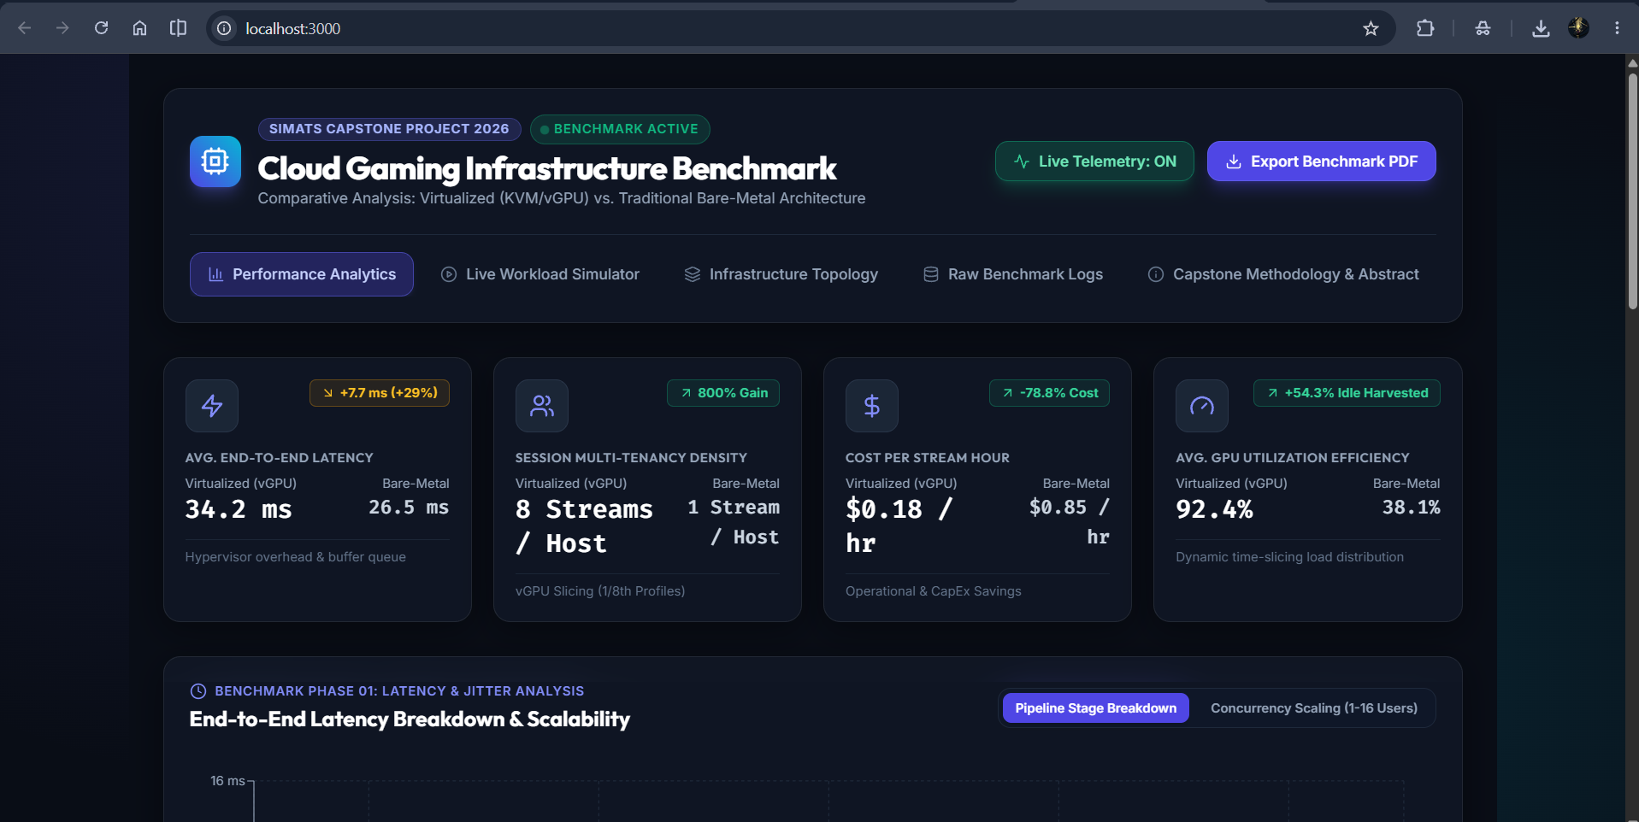
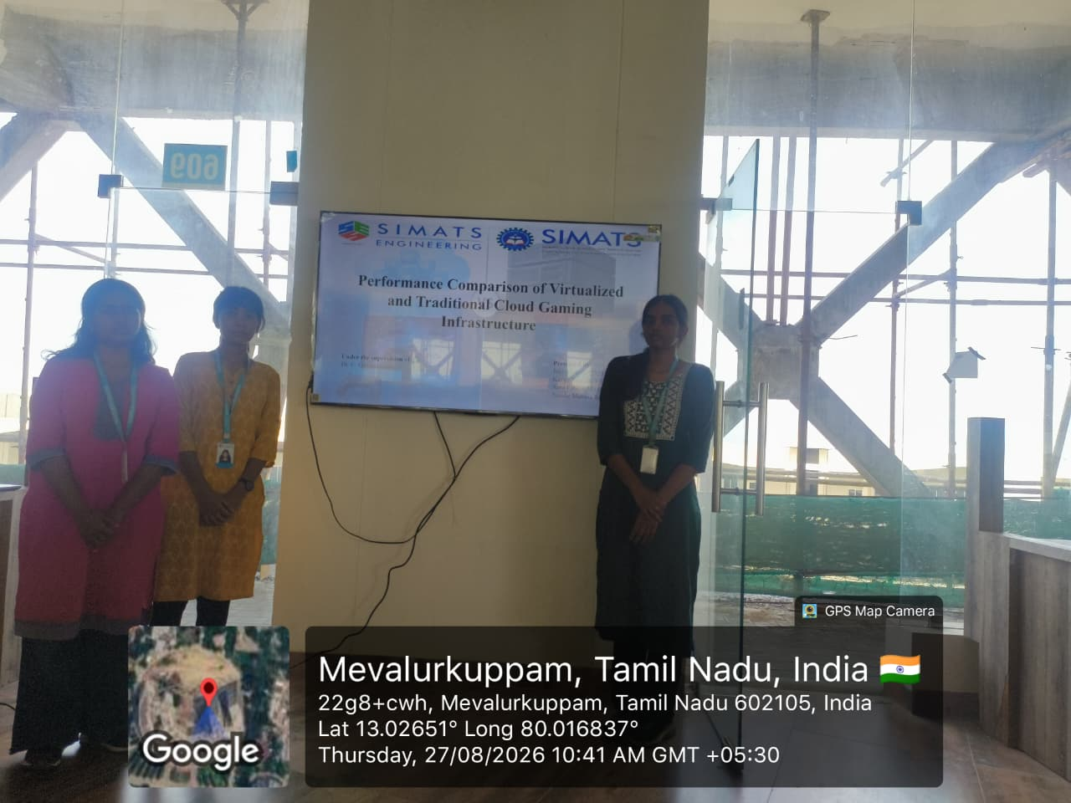
Project Description: Module 3- Performance Data Collection & Big Data Analytics
The project titled “Performance Comparison of Virtualized and Traditional Cloud Gaming Infrastructure” focuses on comparing two different approaches to cloud gaming. Cloud gaming allows users to play games remotely using powerful cloud computing resources, while virtualization allows multiple gaming environments to share and manage cloud resources efficiently. In this project, both virtualized and traditional cloud gaming environments are implemented under comparable conditions. Performance parameters such as FPS, latency, CPU usage, memory usage, GPU usage, and network bandwidth are collected and analyzed. Big data analytics is used to process the collected performance data and identify differences, patterns, and variations between the two environments. The project ultimately helps determine which infrastructure provides better performance and resource efficiency for cloud gaming.

Module 3 focuses on collecting and analyzing the performance data generated by both the virtualized and traditional cloud gaming environments. During this module, important performance metrics such as FPS, latency, CPU, memory, GPU, and bandwidth are continuously recorded. The collected information is organized and stored in structured datasets for further processing. Big data analytics techniques are then applied to identify performance patterns and variations between the two environments. Finally, the collected results are statistically analyzed to determine the differences in performance and resource utilization, providing meaningful insights for the overall comparison of the cloud gaming infrastructures.

Student Signature Guide Signature

